**Project description**

Within my project there are a mix of html, php, javascript, css files and several images. There are also a few images that have been uploaded to imgur.com for use in css files.

- The html files are primarily used for pages with forms and html code is used throughout the php files as well for page structure.

- The php files are used to access, alter and display items in the database created within WAMP and to program the matchmaking between tenant preferences, owner preferences and the postings.

- The javascript file has functions that create links within the html files for switching between pages and validating forms across multiple pages.

- The css file is for styling each of the pages on the website.

The assignment folder should be placed in the “www” folder inside the WAMP directory and run from a browser using “http://localhost/A4/HomePage.html”

The home page is a general information page where the user gets an idea of what the site can do for them. 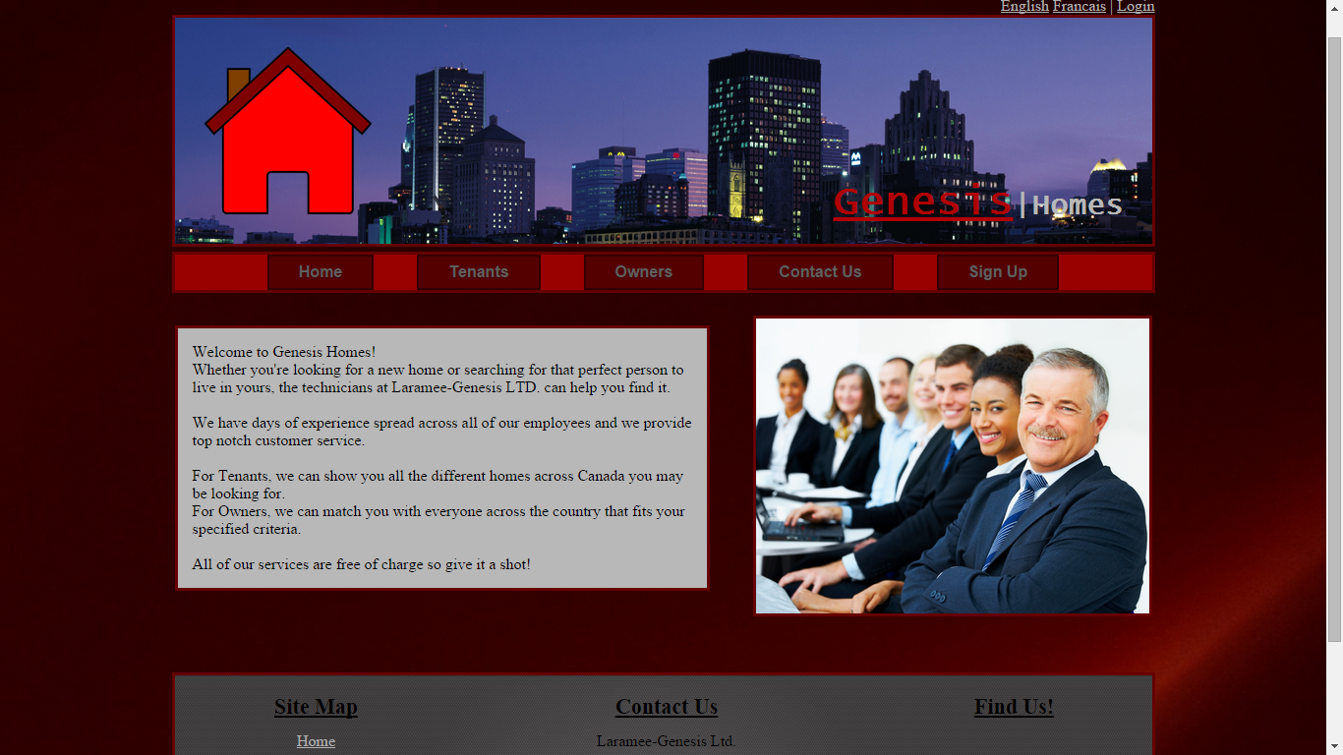

The user, whether a tenant or an owner is expected to register and create themselves a profile with some basic info. Registration takes place at the “Sign Up” page accessed from the menu bar from any page. Submitted information will be written to the database.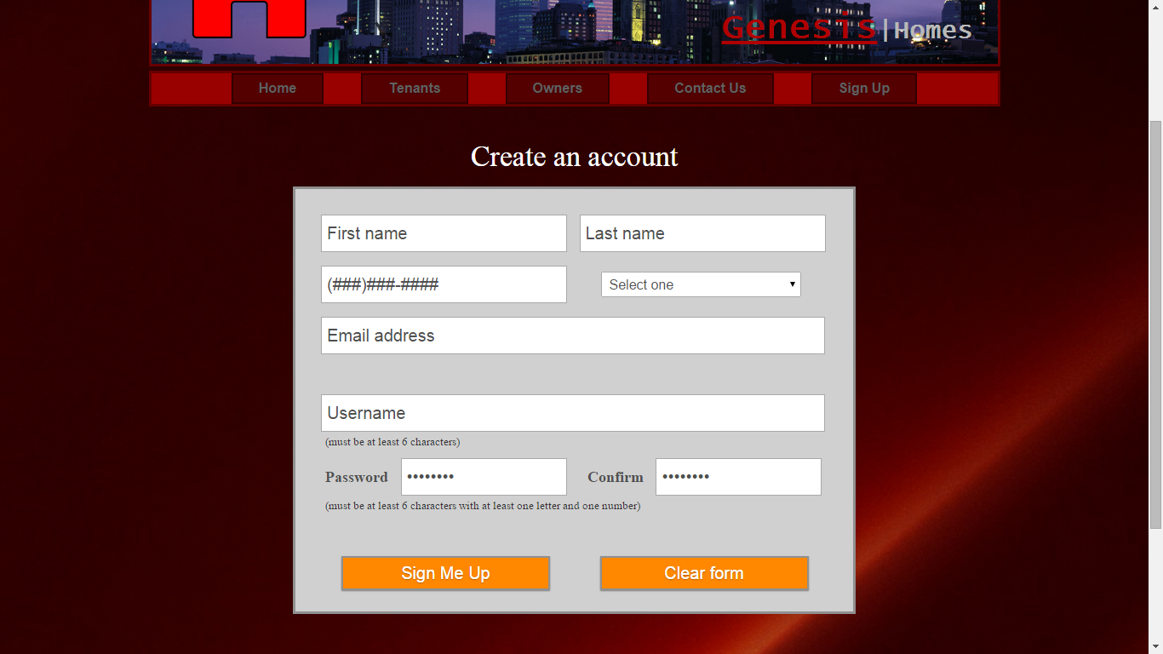

Once the user has created an account they need to login with the username and password they chose in order to start a session. The “Login” link at the top right next to the language selection (which has not been completed) will take the user to the login page. 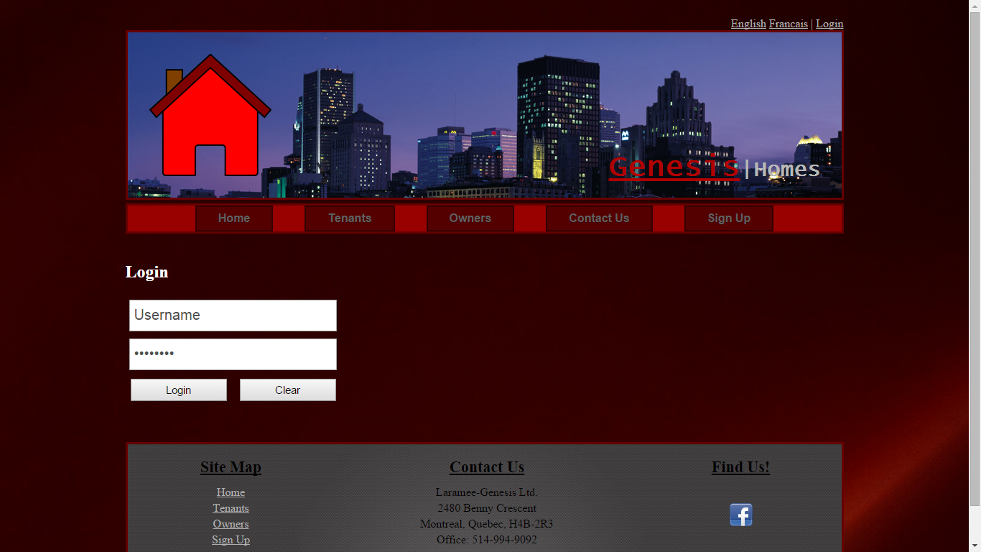 **Tenant:** Once the user has logged in, if they are a tenant, they can navigate to the “Tenant” page accessible from the menu bar to create a tenant profile which specifies some of the criteria their ideal home needs to meet. 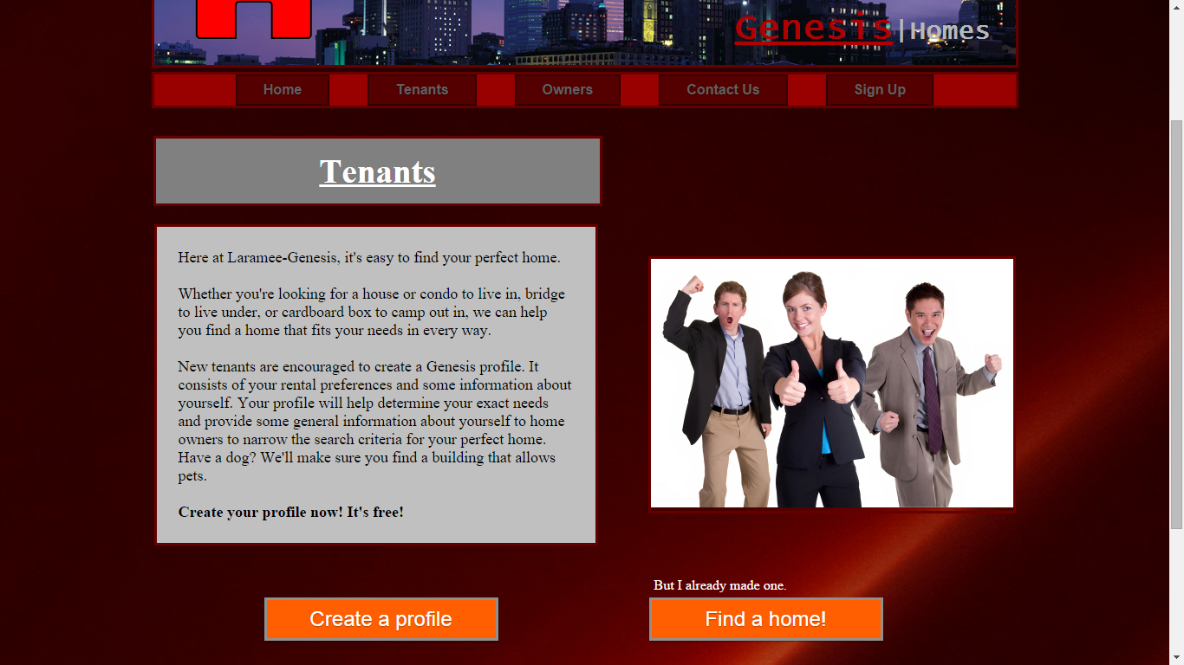

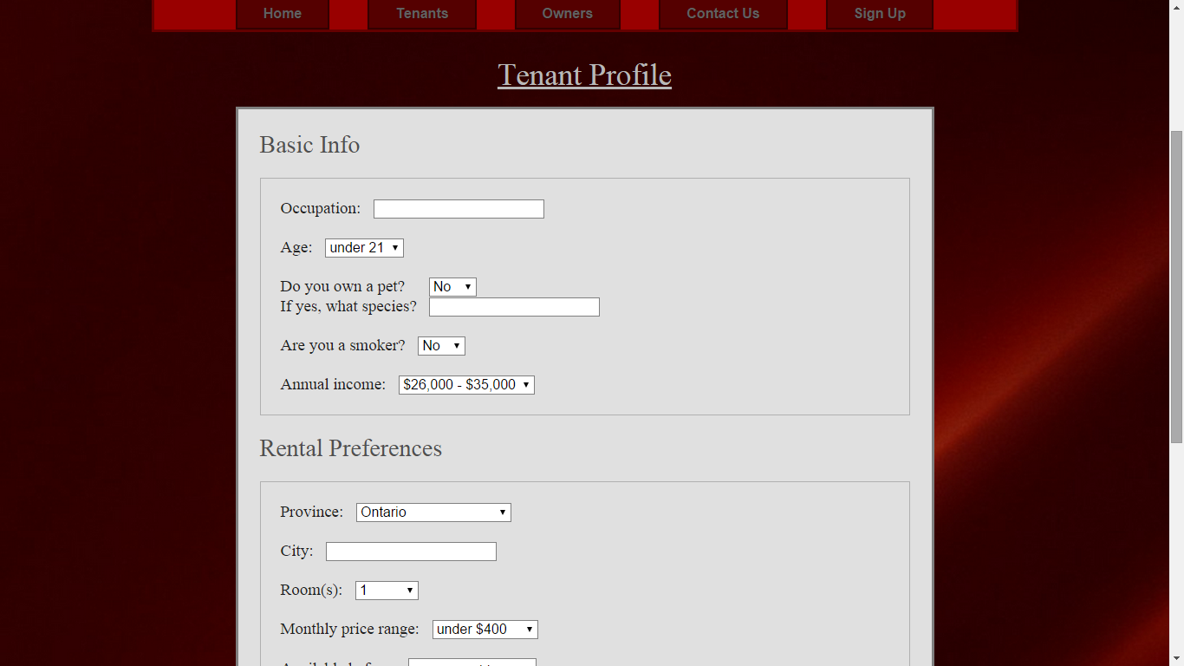

Once this is submitted, it is written to the database in two different tables from their initial registration information and is connected through a unique id. From here the user is ready to search for a property that matches all of their criteria. By clicking “Find a home” from the Tenant page, they can begin the matchmaking process.

**Owner:** Once logged in, the user can go to the “Owner” page and create a profile. This profile covers the owners preferences towards who they want living in their properties. 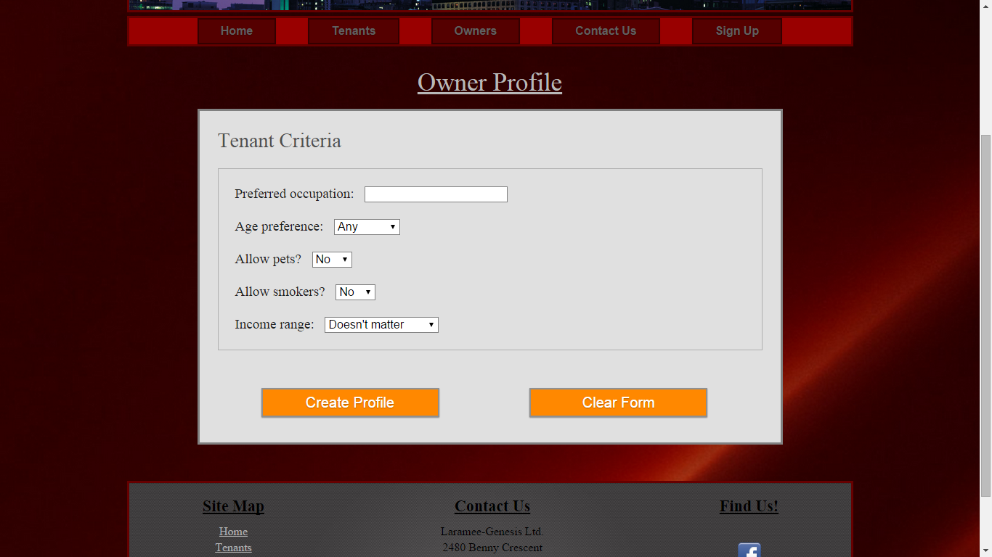

From here the owner can navigate back to the “Owner” page and post a property. The matchmaking will (should have) matched a tenant with an owners property if and only if choices such as allowing smoking and pets were the same between their profiles.

From anywhere on the site, a use can access the “Contact us” page from the menu bar for detailed information on how to contact me with any questions. Basic contact information is also provided in the footer of each page. A link to my facebook is also provided in the footer in case a user would like to know more about me.

If an owner tries to access the tenant profile creation page, they are redirected to the owner page to select an option available to them. The same code is implemented for tenants trying to access the owner profile or property posting page.